**AIM- Design a system for doors at home, such that whenever a door is opened, a light turns on for 1000 ms if it is day & 2000 ms if it is night.**

**Circuit Diagram-**

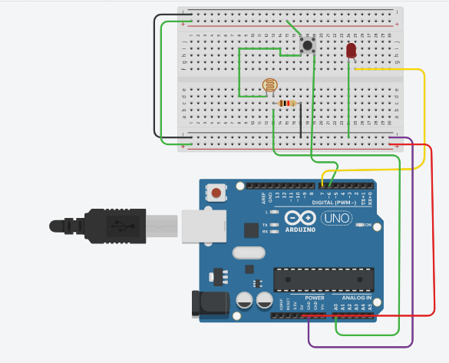

**Theory-**

A Light Dependent Resistor (LDR) is also called a photoresistor or a cadmium sulfide (CdS) cell. It is also called a photoconductor. It is basically a photocell that works on the principle of photoconductivity. The passive component is basically a resistor whose resistance value decreases when the intensity of light decreases. This [**optoelectronic device**](http://www.circuitstoday.com/optoelectronic-devices) is mostly used in light varying sensor circuit, and light and dark activated switching circuits. Some of its applications include camera light meters, street lights, clock radios, light beam alarms, reflective smoke alarms, and outdoor clocks.

**Learning Outcomes-**

After completing the experiment here we are able to learn how the light detector works by detecting the light and acts as instructed by the user and makes the LED to light up.

**Problems and Troubleshooting-**

Improper wiring and correct terminal connection can cause problem, which can be solved, by properly watching and reviewing the connection made.

**Precautions-**

1. Connections should be made properly in the arduino.
2. Basic Syntax mistakes should be avoided while writing the code.
3. The analog and digital pins should not be confused.